Lab 1: MATLAB Onramp Certification (Self-Paced Online Course)

Name: Syed Sualeh Abbas | Student ID: 10303

1.1 Objective
To enable students to successfully complete the MATLAB Onramp course and demonstrate their understanding by performing corresponding lab tasks.

1.2 Background
MATLAB is a high-level technical computing language equipped with a user-friendly interface. Its name stems from the words MATrix and LABoratory as it is based on the use of matrices. It has powerful built-in routines that enable a very wide variety of computations. It also has easy to use graphics commands that make the visualization of results immediately available. Specific applications are collected in packages referred to as toolbox. There are toolboxes for signal processing, symbolic computation, control theory, simulation, optimization, and several other fields of applied science and engineering. MATLAB is an extremely powerful tool useful for scientists and engineers from various disciplines. For example, MATLAB can be used in a wide range of applications, such as telecommunications, signal and image processing, control, mathematics, financial modelling, bioengineering, aeronautics, and many more.
In this lab, we will cover an online course to understand the basics of MATLAB. The duration of this course will be approximately two hours. By the end of this lab, you will have to show the course completion certificate to the instructor. After that, there will be a viva related to the online course.

1.3 Starting MATLAB
To access the ONLINE Version of MATLAB
- Please use the following website to access MATLAB Online on your browser https://matlab.mathworks.com/
- It is mandatory to have a math work account (based on your official Habib university email address)
- Personal math work accounts will not work for MATLAB Online

How to create Mathworks Account
- Go to https://www.mathworks.com/login
- Click on the link "Create Account."
- On the create account page, complete all required fields (Note: Make sure you enter your Habib University email address.) Click "Create" when you're done.
- A page will be displayed with steps you'll need to perform (check for an email from MATLAB, click on the link in the email) so that your email address can be verified. Important: Do not close this window until you've completed these steps.
- Click "Continue" after you have completed the steps to verify your email address. You will be returned to the MathWorks home page, and will be logged in to your new MathWorks account.

Dedicated Portal for download and online training

MATLAB has created a dedicated portal for our university. From there, you will be able to download the latest software, and a license will be automatically assigned to your math work account based on the HU email address.
https://www.mathworks.com/academia/tah-portal/habib-university-31522703.html

Toolboxes to be installed are:
- Simulink
- Signal Processing Toolbox
- Symbolic Math Toolbox
- Image Processing Toolbox
- Image Acquisition Toolbox

Lab Tasks

Task 1: Competence Building
The competence building and mandatory task of this lab is to complete the MATLAB onramp course.
Step 1: Sign in to your MathWorks account (https://www.mathworks.com/).
Step 2: To start the MATLAB onramp course, go to Learn → Online Training and get started.
Attach Course competition certificate below:



Task 2: Matrix Concatenation
Matrix concatenation is the process of joining one or more matrices to make a new matrix. To concatenate two matrices, they must have compatible sizes. In other words, when you concatenate matrices horizontally, they must have the same number of rows. When you concatenate them vertically, they must have the same number of columns.

Try: Type the following in the script file and see the results:

A= [1 2 3]
B= [2 3 6]
C= [A B]
State observations: (Single sentenced answer)
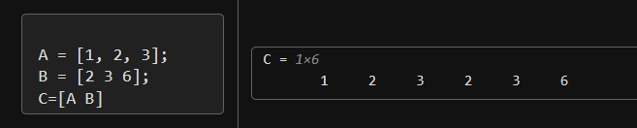
Horizontal concatenation joins matrices side by side and Condition satisfied: same number of rows so, MATLAB combines the elements in sequence without changing their order.

Task 3: Plotting the function

Note: For basic plotting commands and theory refer to the appendix

Try plotting the following functions using the following code provided:
- 𝑚(𝑥) = 𝑥², −3 ≤ 𝑥 ≤ 3 , using step size=1 with black color marker keep the thickness of the trace 2.5
- 𝑛(𝑥) = 2.5 ∗ 𝑥², −3 ≤ 𝑥 ≤ 3, using step-size=0.1 with red color marker
- 𝑝(𝑥) = 2𝑥², −5 ≤ 𝑥 ≤ 5, using step-size=1 with green color marker using * data marker
- Plot 𝑚(𝑥), 𝑛(𝑥) & 𝑝(𝑥) in same figure using (3x1) subplot and giving it a supertitle “Non-Linear graphs”.
Note: ‘suptitle’ command might not work for newer versions of MATLAB, in place of it you can use ‘sgtitle’. If sill this command gives error, then ignore this command and comment it out, these does not work in some MATLAB versions.
- Plot all three functions 𝑚(𝑥), 𝑛(𝑥) & 𝑝(𝑥) in separate figure windows
- Plot all three functions 𝑚(𝑥), 𝑛(𝑥) & 𝑝(𝑥)in the same figure and limit the x-axis to -4 to +4 and y-axis to 0 to 40 and add legend.

Following are the MATLAB codes for plotting the above functions. Run the codes one by one, state observation & attach the results.
Part (a) Code:  % Plotting 1st function subplot (3,1,1) %1st plot x=-3:1:3;  m = x.^2; plot(x,  m,'k','LineWidth',2.5)  title('Plotting m(x)');  xlabel('x'); ylabel('Amplitude');  % Plotting 2nd function subplot (3,1,2) %2nd plot x=-3:0.1:3;  n = 2.5*(x.^2);  plot(x, n,'r')  title('Plotting n(x)');  xlabel('x'); ylabel('Amplitude');  % Plotting 3rd function subplot (3,1,3) %3rd plot x=-5:0.01:5;  p = 2*(x.^2); plot(x, p,'g*')  title('Plotting p(x)');  xlabel('x'); ylabel('Amplitude');  % Adding main/super title  suptitle (‘Non-linear graphs’) %ignore this command if gives error | Part (b) Code:  % Plotting 1st function x=-3:1:3;  m = x.^2; plot(x,  m,'k','LineWidth',2.5)  title('Plotting m(x)');  xlabel('x'); ylabel('Amplitude');  % Plotting 2nd function figure %2nd window  x=-3:0.1:3;  n = 2.5*(x.^2);  plot(x, n,'r')  title('Plotting n(x)');  xlabel('x'); ylabel('Amplitude');  % Plotting 3rd function figure%3rd window  x=-5:0.01:5;  p = 2*(x.^2); plot(x, p,'g*')  title('Plotting p(x)');  xlabel('x'); ylabel('Amplitude'); | Part (c) Code:  % Plotting 1st function x=-3:1:3;  m = x.^2; plot(x,  m,'k','LineWidth',2.5)  title('Plotting m(x)');  xlabel('x'); ylabel('Amplitude');  % Plotting 2nd function x=-3:0.1:3;  n = 2.5*(x.^2);  hold on plot(x, n,'r')  title('Plotting n(x)');  xlabel('x'); ylabel('Amplitude');  % Plotting 3rd function x=-5:0.01:5;  p = 2*(x.^2); plot(x, p,'g*')  title('Plotting p(x)');  xlabel('x'); ylabel('Amplitude');  axis([-3,3,0,40])  legend(‘m’,’n’,’p’)  hold off

PART A

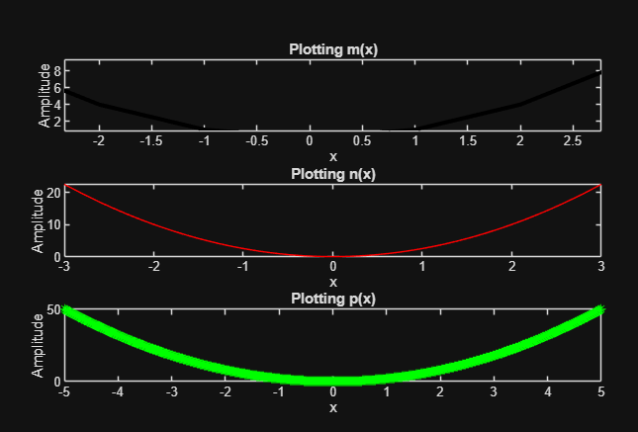

PART B
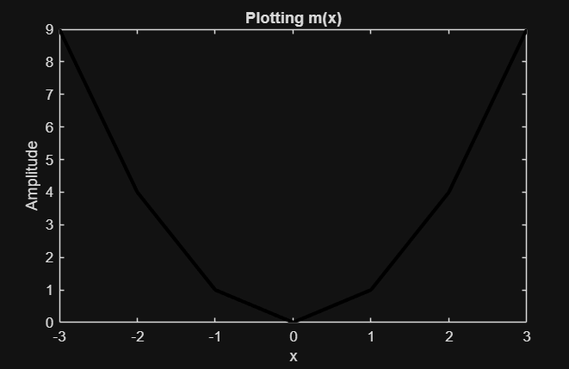
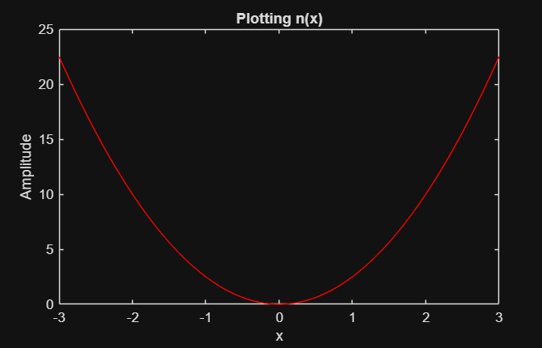
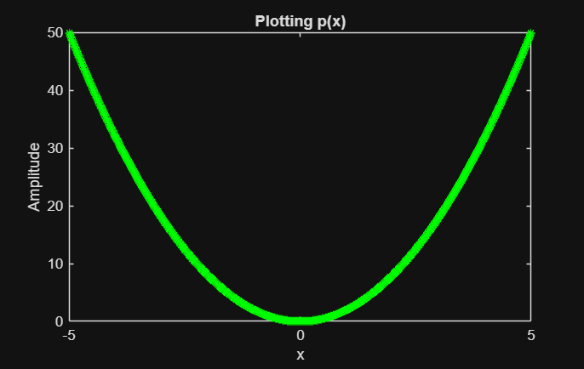

PART C
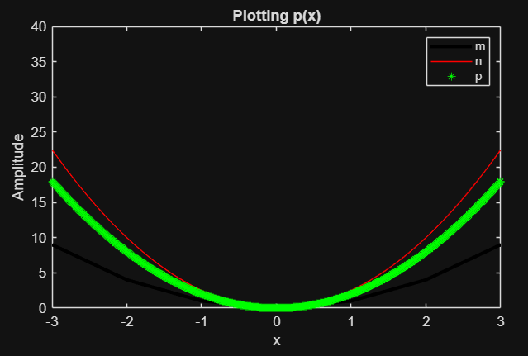

Task 4
(a) Explore the following using MATLAB help:
zeros, ones, rand, eye.
(b) Create a $2 × 3$ matrix containing arbitrary data. Explore using the MATLAB functions zeros, ones, eye, and rand to create the matrix. Find a way to use the square matrix eye(2) as part of your $2× 3$ matrix.Verify the sizes of your arrays using size.
(c) Create an array that is a row vector of length 36, with zeros everywhere except in the 18th position, which has value 1. (Hint: Try help zeros to find a way to create a row vector with just zeros, and then assign the 18th element of this vector the value one.)

Copy and paste the code and attach the results below.

PART A&B:
CODE:
A=rand(2,3)
B=zeros(5,6)
c=ones(3,4)
I=eye(2)
M=[I ones(2,1)]
size(M)

RESULT:
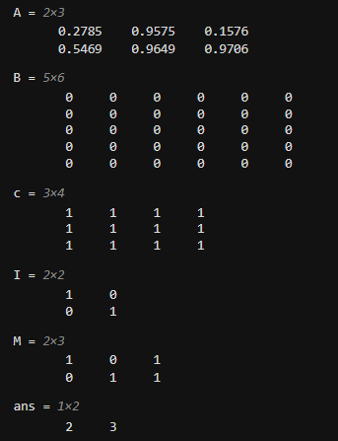

PART C:
CODE:
A=zeros(1,36)
A(18)=1

ANSWERS:
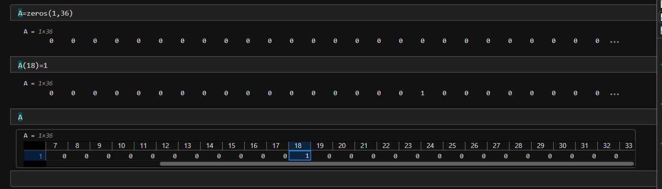

Appendix:

Plotting the function
MATLAB is a very reliable and power full tool for plotting. A graph is constructed as a set of points in two or three dimensions. These points are typically connected with a solid line. Commonly a graph of a function is required. However, in MATLAB a plot is done using the vectors and matrices not functions.

Commands:
plot(X,Y) %This MATLAB function creates a 2-D line plot of the data in Y versus the corresponding values in X, where length of both the vectors should be same
title % adds the specified title
xlabel % adds label to the x-axis in a plot
ylabel % adds label to the y-axis in a plot

subplot(m,n,p) % This MATLAB function divides the current figure into an m-by-n grid and creates axes in the position specified by p. where m=row, c=columns and p=plot number
suptitle1 % Super title, when we make more than one plots in a figure and want to add a main or super title then this command is used
plot(t, x, 'LineWidth',2) %linewidth defines the thickness of the signal plotted
grid on % adds grid lines to the current axes or chart.
grid off % grid off removes all grid lines from the current axes or chart.
hold on % retains the current plot and certain axes properties so that subsequent graphing commands add to the existing graph.
hold off % resets axes properties to their defaults, hold off is the default.
legend % to label data series plotted on a graph
axis(limits) % specifies the limits for the current axes
figure % creates a new figure window using default property values. If there are more than one figures and we want to see the results at once of all then, after 1st figure before plotting the upcoming figures, we use this command (i.e., before the plot command).
It is possible to create a graph using colors, symbols used to draw the points, and type of line that connects the points of your choice. This is achieved by applying one more input argument to the command Plot The new argument is a series of special character given in single quotes. The available special characters are presented in the table below.
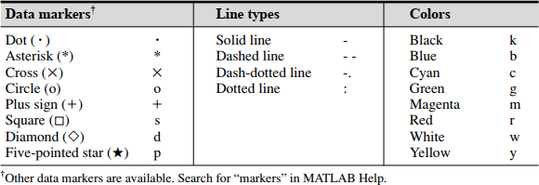

Plotting in Two Dimensions

Suppose that we want to plot a function 𝑦(𝑥), where ‘𝑥’ is an independent variable. The procedure to plot 𝑦(𝑥) is as follows:
- Vector x is created. Such as 𝑎 ≤ 𝑥 ≤ 𝑏, where a and b are scalars.
- The function will be plotted over the interval [𝑎, 𝑏]
- Create the vector 𝑦, which is of the same length as 𝑥. The two vectors must have an equal number of elements.
- The value of each element of 𝑦 is the value 𝑦(𝑥) of calculated for each value of 𝑥.
- Finally, the function 𝑦(𝑥) is plotted by typing plot(x,y)

Lab 1: MATLAB Onramp Certification (Self-Paced Online Course)

Habib University

EE/CE-252L/251L Signal and Systems

Name: _________________________________ Student ID.: ___________________

Marks distribution:

 |  | LR2  Code | LR5  Results | AR4  Report Submission
In-Lab  Tasks | Task 1 |  | /60 | /10
In-Lab  Tasks | Task 2 |  | /10 | /10
In-Lab  Tasks | Task 3 | /5 | /5 | /10
In-Lab  Tasks | Task 4 | /5 | /5 | /10
In-Lab  Tasks |  | /10 | /80 | /10
CLO Mapped |  | CLO1
Total Marks |  | /100

Affective Domain Rubric |  | Points | CLO  Mapped
AR 4 | Report Submission | /10 | CLO 3

CLO | Total Points | Points Obtained
1 | 90
2 | -
3 | 10
Total | 100

For description of different levels of the mapped rubrics, please refer the provided Lab Evaluation Assessment Rubrics and Affective Domain Assessment Rubrics.

For every task it is required to copy paste the code and not attach the snippet of code, however, screenshot of meaningful part of results can be attached, be mindful of visibility when attaching snips.

